## Proforma Receipt

Receipt No: ORBIT/2025/1/{{receipt_no}} Date [DD/MM/YYYY]: {{date}}

**Received from:**

Customer Name: {{customer_name}}

Address: {{address_line1}}

Phone Number: {{phone}}

Email (if available): {{email}}

**Payment Details:**

Amount Received: ₹ {{amount_received}}/-

Payment Mode: {{payment_mode}}

Reference ID (if available): {{reference_id}}

Date of Payment [DD/MM/YYYY]: {{payment_date}}

**Towards:**

Advance booking for Orbit PT Pro Electric Power Tiller

Balance amount of ₹ {{balance_due}}/- to be paid before delivery.

Tentative delivery date [DD/MM/YYYY]: {{tentative_delivery}}

**Acknowledgement:**

We acknowledge receipt of the above-mentioned amount as advance towards booking of the Orbit PT Pro. This receipt confirms the reservation of your machine. The final invoice will be issued at the time of full payment and delivery.

**Authorised Signatory**

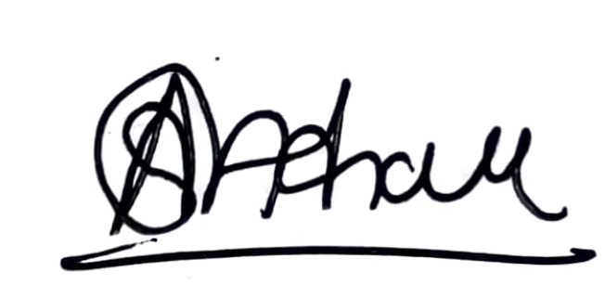

For Higher Orbit Agritech Pvt. Ltd.

GST: 27AAHCH1976Q1ZS

## Annexure

{{items_table}}